Handlebar Control Reverse/Start Button Kit

Please read instructions before beginning the installation of Handlebar Control Reverse/Start Button Kit

Parts included in kit:  1.If equipped with a handlebar cover remove the cover.  2.Carefully remove existing reverse button.  3. Loosen all four cap screws securing the handlebar  cap to the riser.  4.Then rotate the handlebar so the control is facing upwards.  5. Install new spring into the cavity of the left-side handle-  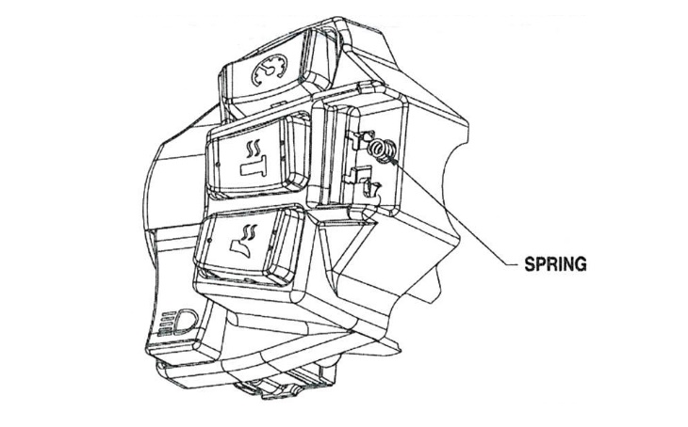  bar control. As shown below  ■ PLEASE NOTE: There are two springs include in  reverse button kit. Only one is required when  installing new button. Second spring is provided in case one is lost during installation. | 4. Align one side of tabs on the reverse button with the  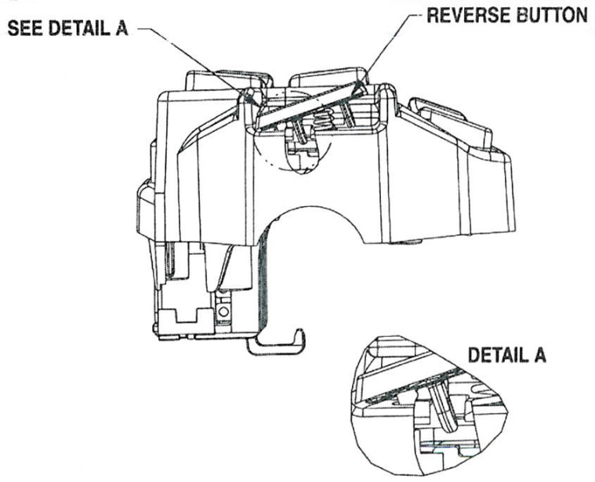  tab on left handle-bar control. As shown below  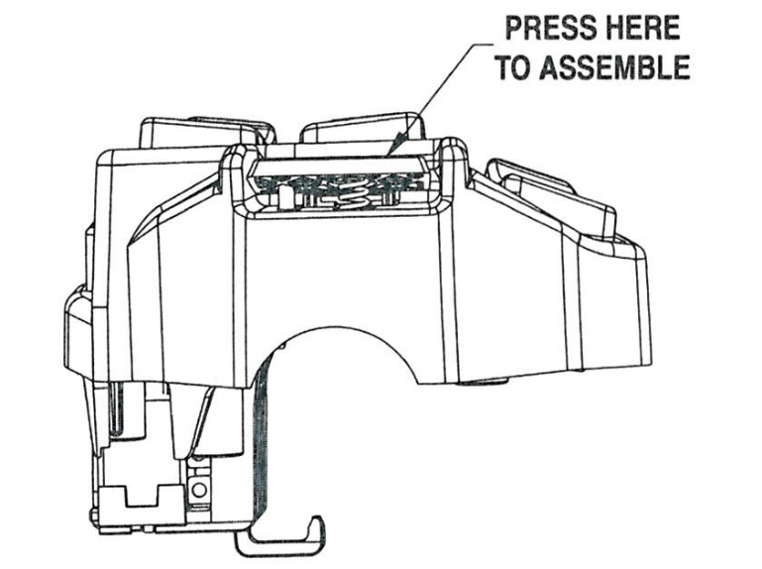  5. Press the reverse button above the other tab to snap button into place. This will align the button with the tab in the left handle-bar control. As shown below  6. Readjust the handlebar to operator’s desires position,  The cap screws can then be evenly tightened to 15 ft-lb.
  QTY | DESCRIPTION
  2 | Spring
  1 | Reverse Button
  1 | Instruction

